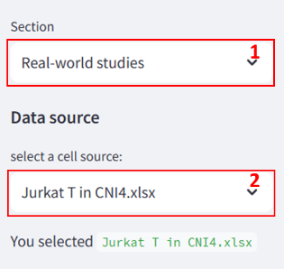
Handbook v1.0
Real-world study
- To enable real-world studies, please select the “Real-world studies” section on the right sidebar.
- Select a cell source by choosing a file name from the drop-down menu, e.g., “Jurkat T in CNI4.xlsx”. After selection, the currently selected file will be displayed in the text below.
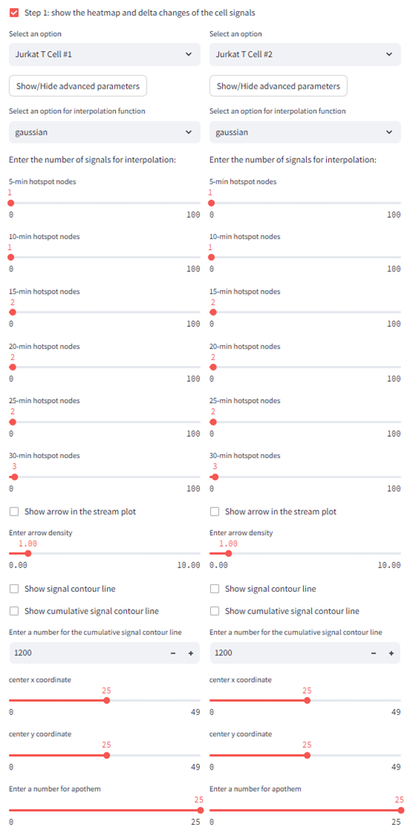
Step 1: Show the heatmap and delta changes of the cell lines
- Select the cells to be compared by choosing the cell names, e.g., “Jurkat T Cell #1” versus “Jurkat T Cell #2”.
Optional (The parameters in generating the three-layer signal heatmap):
- Select an interpolation function, e.g., “2D gaussian” among the functions “gaussian”: $exp\left(-{\left(\frac{r}{epsilon}\right)}^{2}\right)$, multiquadric: $sqrt\left({\left(\frac{r}{epsilon}\right)}^{2} + 1\right)$, inverse: $\frac{1.0}{sqrt\left({\left(\frac{r}{epsilon}\right)}^{2} + 1\right)}$, linear: $r$, cubic: $r^{3}$, quintic: $r^{5}$, and thin plate: $r^{2}×log\left(r\right)$. The r represents radius. The epsilon is an adjustable constant for gaussian or multiquadrics functions - defaults to approximate average distance between nodes.
- Specify the number of hotspot nodes based on their signal level from high to low. The signal velocity layer's flow potential, indicated by arrows, will start from the designated number of specifically chosen hotspots.
- Toggle stream plot arrows by checking the box.
- Adjust arrow density ranging from 0 to 10.
- Toggle signal interpolated heatmap’s contour lines and cumulative signal contour heatmap’s contour lines by checking the box respectively. Set the cutoff for cumulative signal contours with a number.
- Select the center coordinates and diameter.

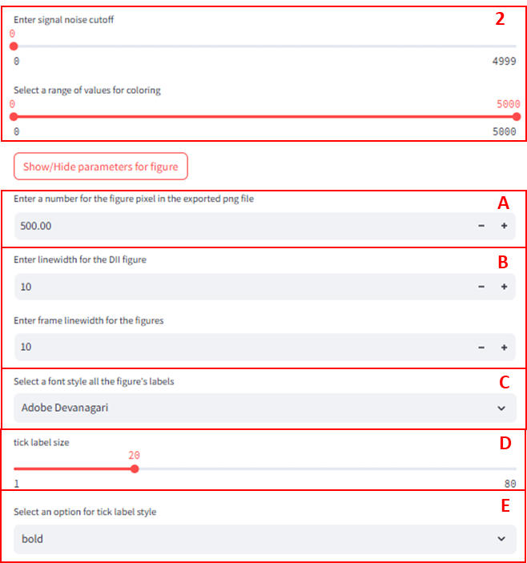
- Enter the signal noise cutoff and select a range of values for coloring. The noise cutoff will set signals below the cutoff to 0. The coloring will apply to signals within the specified range of values.
Optional (The parameters in generating the figure):
- Enter a number for the figure pixel in the exported .png file. The default value is 500.
- Enter linewidth and frame linewidth for the figure. The default value is 10.
- Select a font style by choose the name of the font in the drop-down menu.
- Choose the tick label size. The value is from 1 to 80.
- Select the tick label style. The default is bold.
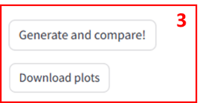
- Click on the “Generate and compare!” button to generate the signal heatmap. Click the “Download plots” button to download all the figures in bulk.

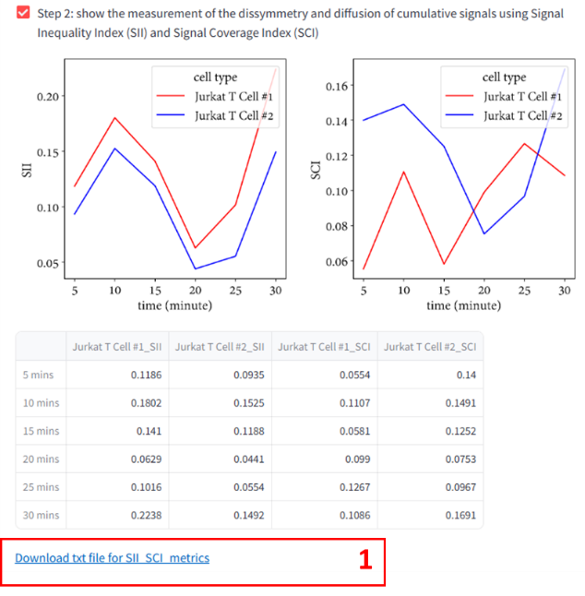
Step 2: Show the measurement of the dissymmetry and diffusion of cumulative signals using Signal Inequality Index (SII) and Signal Coverage Index (SCI)
- The SII and SCI plot will be automatically generated after clicking on the “Generate and compare!” button. The line in different colors represents the selected cells for comparison, e.g, “Jurkat T Cell #1” versus “Jurkat T Cell #2”. A table will provide the values of SII and SCI results. Click on the downloadable link “Download txt file for SII and SCI metrics”

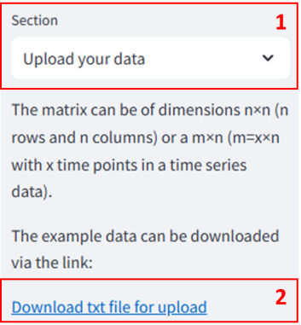
Upload your data
- To upload customized data, please select the “Upload your data” section on the right sidebar. The matrix can be of dimensions $n×n$ ($n$ rows and $n$ columns) or a $m×n$ ($m=x×n$ with $x$ time points in a time series data).
- To download the demo or example in .txt file, click on the link “Download .txt file for upload”.
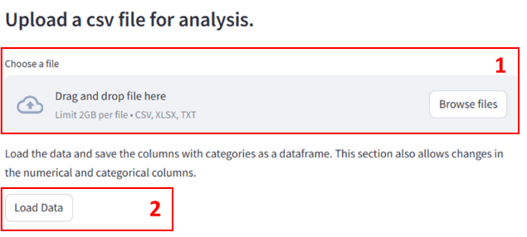
Step 1: Show the heatmap and delta changes of the cell lines
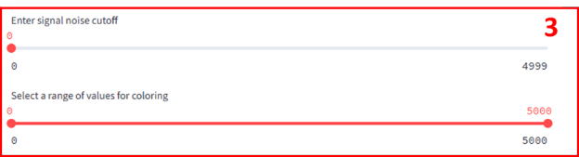
- Upload a file by either dragging and dropping it or clicking on the "Browse files" button. The file type can be .csv, .xlsx, or .txt.
- Click on the “Load Data” button to upload the file.
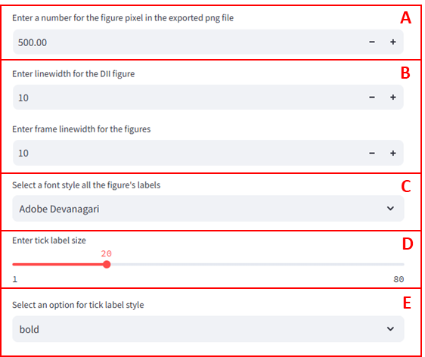
- Enter the signal noise cutoff and select a range of values for coloring. The noise cutoff will set signals below the cutoff to 0. The coloring will apply to signals within the specified range of values.
Optional (The parameters in generating the figure):
- Enter a number for the figure pixel in the exported .png file. The default value is 500.
- Enter linewidth and frame linewidth for the figure. The default value is 10.
- Select a font style by choose the name of the font in the drop-down menu.
- Choose the tick label size. The value is from 1 to 80.
- Select the tick label style. The default is bold.

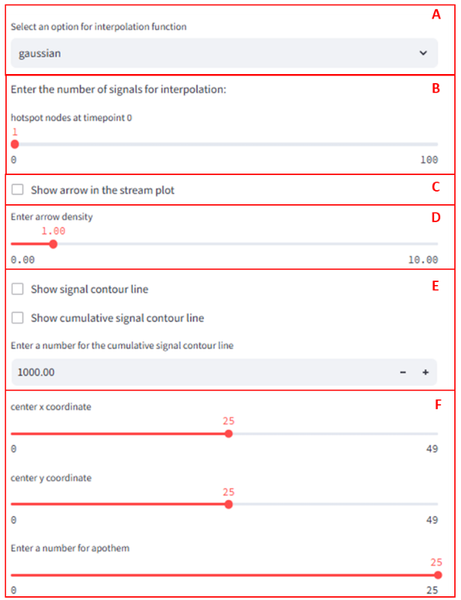
Optional (The parameters in generating the three-layer signal heatmap):
- Select an interpolation function, e.g., “2D gaussian” among the functions “gaussian”: $exp\left(-{\left(\frac{r}{epsilon}\right)}^{2}\right)$, multiquadric: $sqrt\left({\left(\frac{r}{epsilon}\right)}^{2} + 1\right)$, inverse: $\frac{1.0}{sqrt\left({\left(\frac{r}{epsilon}\right)}^{2} + 1\right)}$, linear: $r$, cubic: $r^{3}$, quintic: $r^{5}$, and thin plate: $r^{2}×log\left(r\right)$. The r represents radius. The epsilon is an adjustable constant for gaussian or multiquadrics functions - defaults to approximate average distance between nodes.
- Specify the number of hotspot nodes based on their signal level from high to low. The signal velocity layer's flow potential, indicated by arrows, will start from the designated number of specifically chosen hotspots.
- Toggle stream plot arrows by checking the box.
- Adjust arrow density ranging from 0 to 10.
- Toggle signal interpolated heatmap’s contour lines and cumulative signal contour heatmap’s contour lines by checking the box respectively. Set the cutoff for cumulative signal contours with a number.
- Select the center coordinates and diameter.
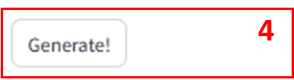
- values for coloring. The noise cutoff will set signals below the cutoff to 0. The coloring will apply to signals within the specified range of values.

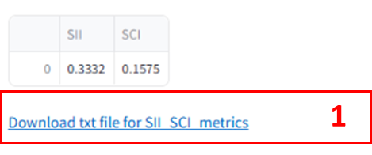
Step 2: Show the measurement of the dissymmetry and diffusion of cumulative signals using Signal Inequality Index (SII) and Signal Coverage Index (SCI)
- The SII and SCI plot will be automatically generated after clicking on the “Generate!” button. A table will provide the values of SII and SCI results. Click on the downloadable link “Download txt file for SII and SCI metrics”

